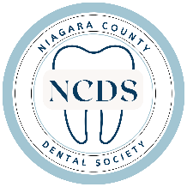

We invite you to become an exclusive sponsor of the Niagara County Dental Society’s upcoming Christmas Party. This is an exceptional opportunity to showcase your company’s brand, products and/or services in front of key industry professionals who are either using your brand or could greatly benefit from learning more about what your company provides all while mingling and enjoying Holiday Festivities.

**Gold Sponsorship ($1000)**

* Company logo featured in a prime position on banners and on our website
* 2 tickets* to attend the 2024 Christmas Party (a $200 value)

**Silver Sponsorship ($500)**

* Company logo featured on event banners and on our website
* 2 tickets* to attend the 2024 Christmas Party (a $200 value)

**Bronze Sponsorship ($499-$100)**

* Company logo featured on event banners and on our website

Please send sponsorship checks and email your company logo by November 25, 2024

The Niagara County Dental Society

4538 Sharon DR

Lockport, NY 14094

Email: Dr.JackieSez@gmail.com

*Additional tickets are available for $100

Company:__________________________________________________________

Sponsorship Level: Gold          Silver          Bronze

Party Attendants: __________________________ & __________________________